Task 1.9.1

2. Insert screenshot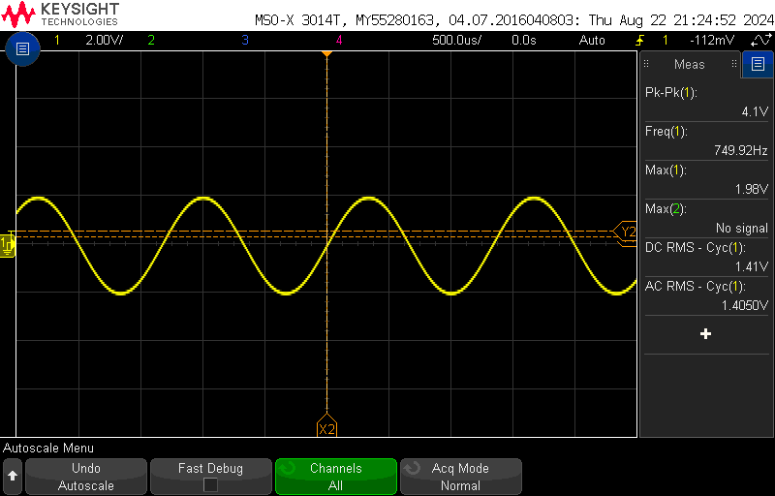

4. Changes voltage level at which oscilloscope is looking for wave

5. Adjusting horizontal offset changes the time delay or phase of the wave

6. Adjusting vertical offset changes vertical position of wave or DC offset

10. DC: 3.2997 V, AC: 1.2 mV

Task 1.9.2

6. input, output, screenshot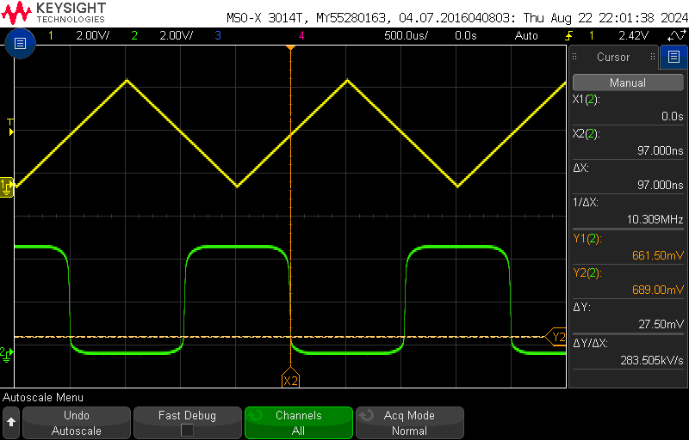

7. transfer characteristic screenshot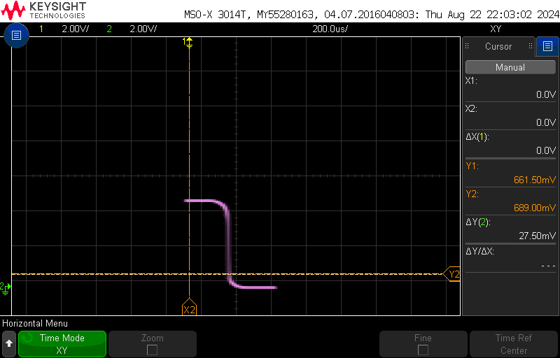

8. transfer characteristic screenshot w cursors fig 1.6

Transfer characteristic w noise margin cursors

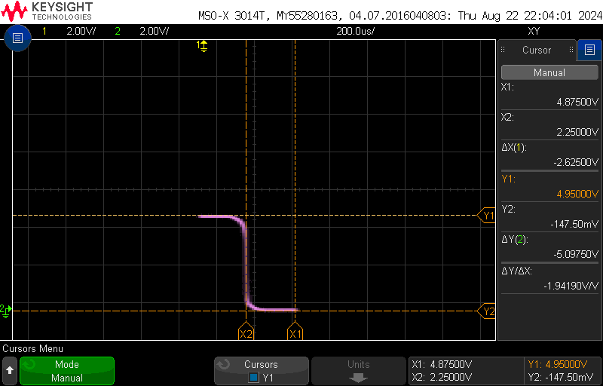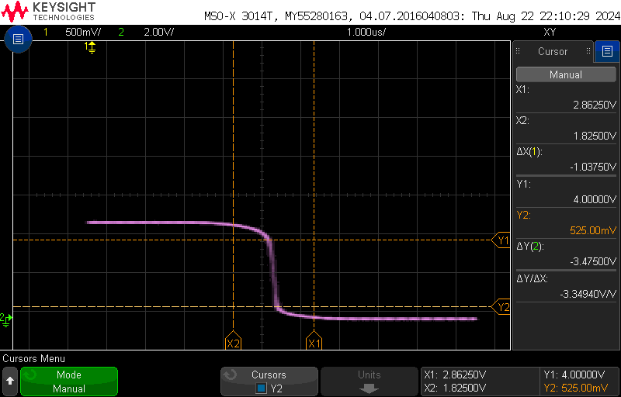

Task 1.9.2

2. ring oscillator frequency

3. ro propagation delay